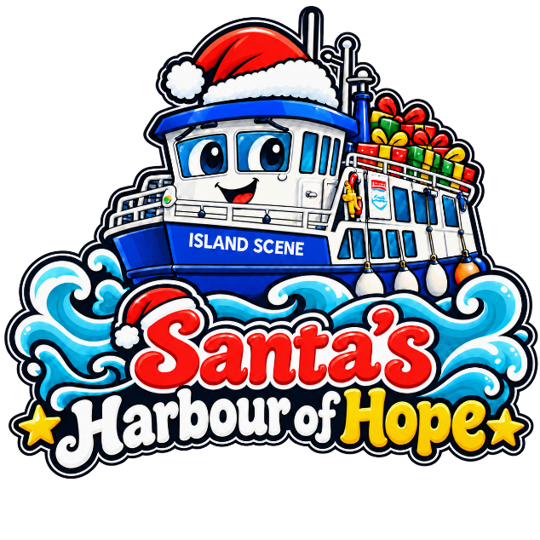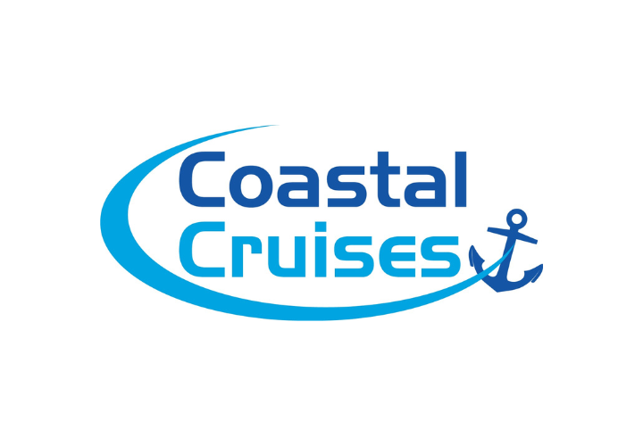
Drop off a gift. Share a little Christmas magic. 🎁
One extra present in your shopping basket could bring a moment of joy to a local child — and ease a little worry for a family facing a difficult Christmas.
Help us fill Santa’s Harbour of Hope with kindness by donating a new, unwrapped gift, from now until 6th December.
What can I donate?
We welcome gifts for children of all ages, including teenagers, who can sometimes be overlooked in Christmas appeals.
Ideas include:
- Gift vouchers, giving older children the chance to choose something they love.
- Gifts for teenage boys, including games, toiletries and cosy clothing.
- Make-up, nice toiletries and pampering treats for teenagers.
- Sensory toys and gifts.
- LEGO, games, toy cars and dolls.
- Arts and crafts, including kits suitable for older children.
- Cuddly socks, blanket hoodies and cosy blankets.
- Chocolates and sweets.
Please leave gifts unwrapped, so they can be matched to a suitable child.
Where to drop off your gifts
Coastal Cruises Poole
Cobbs Quay Marina
Woodlands Avenue
Poole, BH15 4EL
Come through the barrier, turn left and you’ll find us next to Powerboat Training UK. Free parking for gift drop-offs.
Coastal Cruises Blue Kiosk
The Quay
Poole, BH15 1HJ
You can also hand your donation to our team aboard Solent Scene, Island Scene or Fortuna when the boats are alongside Poole Quay.
If you can’t get to us and would like to donate email sales@coastalcruisespoole.co.uk or call 07483 038487 and we will do our best to come and pick them up.
Every gift matters. Thank you for helping a local child feel the magic of Christmas. ❤️

