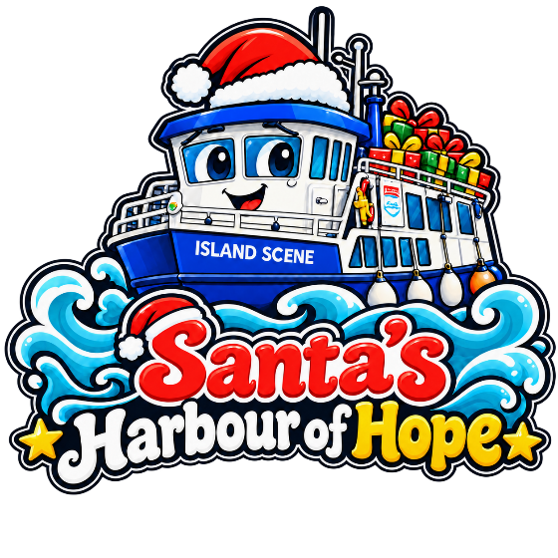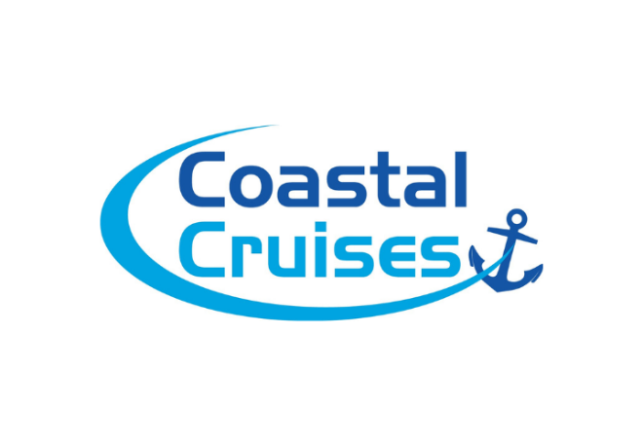
Bring your business aboard Santa’s Harbour of Hope
This Christmas, we’re inviting local businesses to help us fill our boat with new, unwrapped gifts for local children whose families are facing difficult times.
A single extra gift can mean so much — the excitement of opening a present, a moment of happiness, and a little less worry for a parent trying to make Christmas special.
Your business can help by:
- Collecting gifts from your customers / team through a workplace “Buy One Extra” appeal.
- Donating presents as part of your company’s Christmas giving.
- Spreading the word through your social media, newsletters and networks.
Whether you’re a small team collecting a handful of presents or a larger business bringing colleagues together, every contribution will help. We’d love to recognise your support through our campaign updates, too.
Get in touch with Coastal Cruises Poole to discuss how your business can take part. sales@coastalcruisespoole.co.uk 07483 038487
Together, we can fill a boat with gifts — and bring a little Christmas magic to the children who receive them.

