

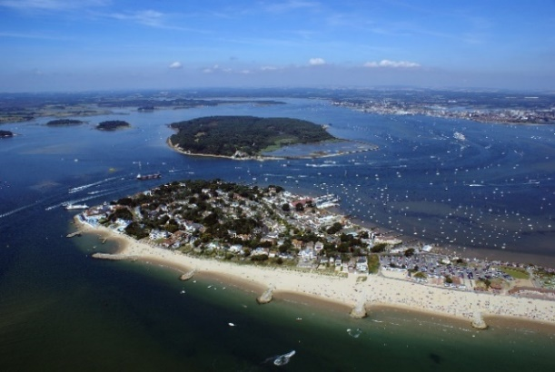
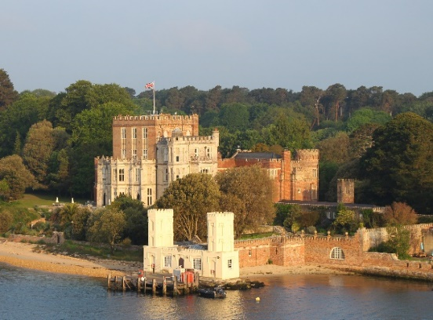
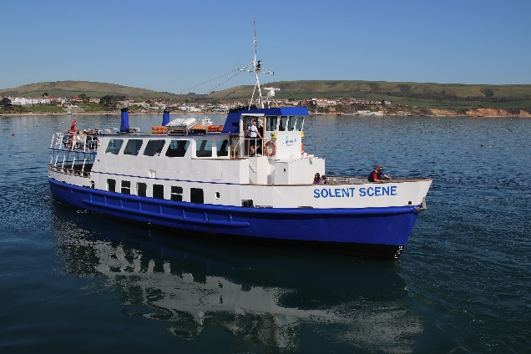

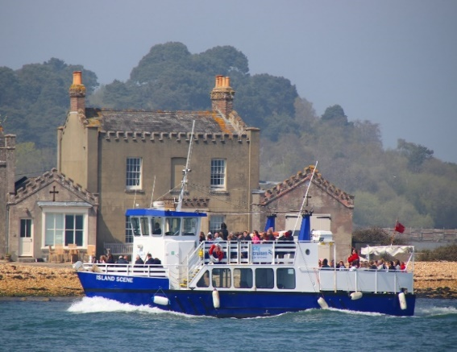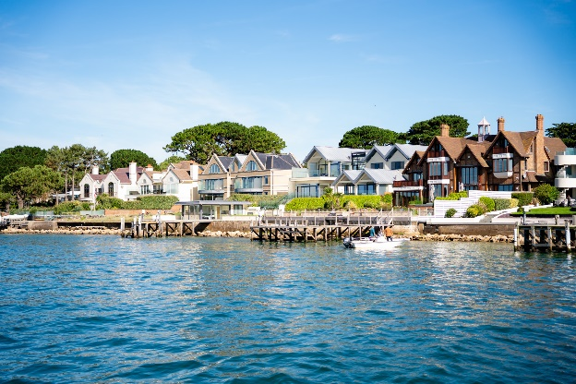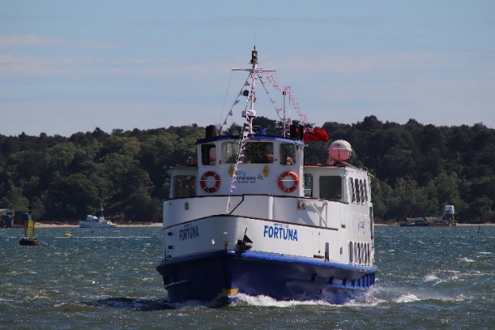

WE HAVE A DIFFERENT VIEW OF CAPTURING MEMORIES

Charter Brochure 2025

To book, please call 07483 038487 or email sales@coastalcruisespoole.co.uk

Why use Coastal Cruises Poole?
Coastal Cruises Poole Ltd is an excellent choice for anyone seeking a memorable private charter and a scenic cruise along the Dorset Coastline or in Poole Harbour. As a family run business we have a wealth of knowledge and experience on running private charters and insight into the local area to ensure your event is a huge success. We have arranged hundred’s of private charters and our professional and knowledge crew and well maintained fleet of boats will ensure your event is fun, easy to arrange and thoroughly enjoyable!
What more can you offer for my private event?
We have plenty more than just a private cruise for you! We have some of the finest food available in Dorset, along with all forms of entertainment. Not sure what you’re looking for? We can find the right fit for you, from our wide range of acts we have worked with in the past, or our in-house DJ who is tried and tested to be the best! The partnership with our professional caterers allows you to hand pick your food selection, making sure all your desires are met efficiently.
How are we different?
With the standard and quality of our services, you will want for nothing. With a team readily available to hand craft your event, you can relax as our experienced sales team take care of every detail. Our knowledgeable Captains and crew have over 30 years’ experience on the water and will be there to make sure your event goes to plan with ease.

THE FLEET
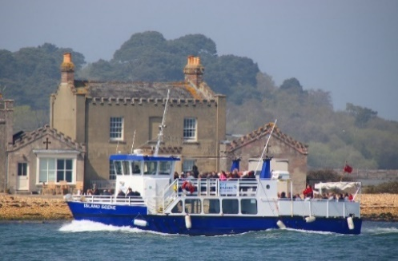
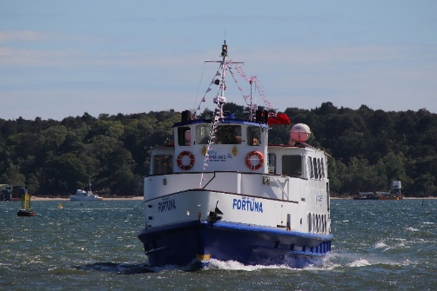
Solent Scene Fortuna Island Scene

Open air viewing areas | Boats designed for all-weather visibility | Daytime and evening departures | Catering options | Fully stocked licensed bars | Toilets
Cruises available along The Jurassic Coast to Swanage Bay and Poole Harbour & Islands Cruise

SOLENT SCENE

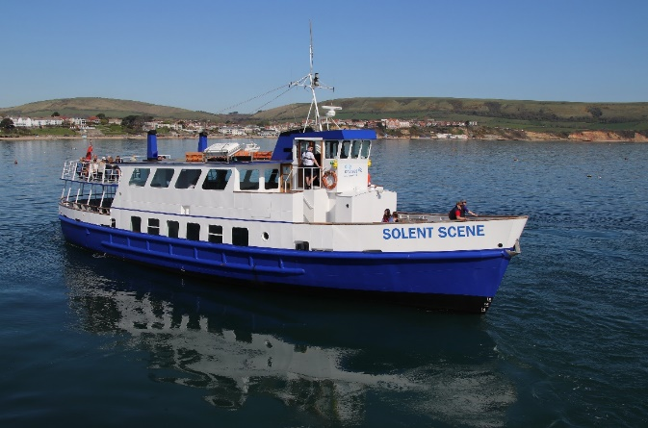
3 Hour Evening Hire
(Sunday – Wednesday) April, May, June, July, August Sept & Oct £1200
3 Hour Evening Hire
(Thursday – Saturday) April, May, June, July, August Sept & Oct £1650
Fireworks nights @ £2000
3 Hour Evening Hire November - March £1000
All week
Day Time Hire November - March £650 per hour
April – October £800 per hour

(Any Day)
Solent Scene is the largest vessel of its type operating in the Poole & Swanage area. We can accommodate up to 140 passengers on a daytime cruise and up to 120 on an evening function.
It is one of our vessel’s with two separate internal saloons, incorporating the bar and quiet lounge on the lower deck and the disco and dancefloor on the upper deck. In addition to this, she also has two large outside decks.

Facilities:
- 2 toilets
- Dance floor area
- Public announcement system
- iPod/aux music system
- Fully stocked bar
- Open air decks
*Please note for daytime hire, it is a minimum 2 hour hire, and in the peak season it is a minimum of 3 hour hire for all boats.
All evening hires are a 3 hour inclusive cruise, 7.00pm – 10.00pm. Extension for an extra fee can be discussed.

ISLAND SCENE

Island Scene is our smaller vessel, which is for more bespoke cruises and can accommodate up to 100 guests on a daytime cruise and 80 on an evening cruise, depending on your event requirements.
Island Scene is perfect for the more intimate gatherings, where you can mingle and entertain with ease.
There are 2 large outside decks and an indoor saloon with a well-stocked bar. With quaint booths for your guests to sit, catch up in and enjoy the outstanding views.

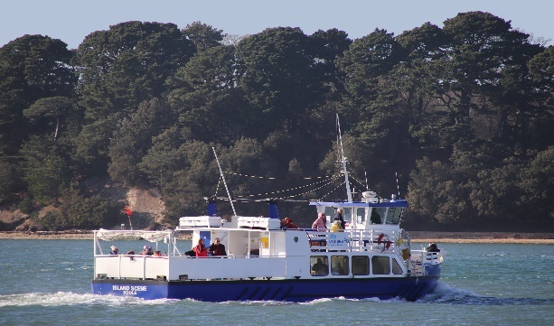
3 Hour Evening Hire
(Sunday – Wednesday) April, May, June, July, August ,Sept & Oct £850
3 Hour Evening Hire
(Thursday – Saturday) April, May, June, July, August, Sept & Oct £1100 (Firework nights @ £1300)
3 Hour Evening Hire November – March @ £650
All week
Day Time Hire November – March £500.00 per hour
April – October £600.00 per hour

Facilities:
- 2 toilets
- Inside saloon booth seating
- Public announcement system
- iPod/aux music system
- Fully stocked bar
- Rain cover for back deck

- Open air decks

The Fortuna
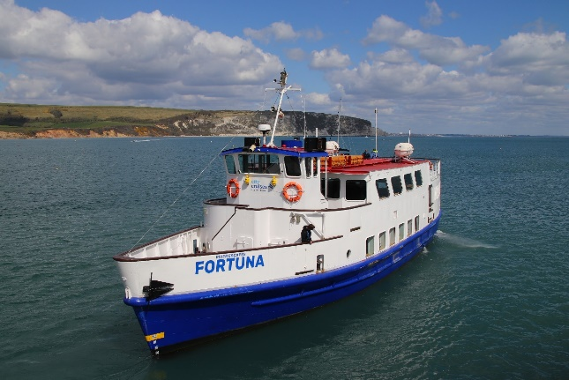
The Fortuna is the sister ship to the Solent Scene. We can accommodate over 140 passengers on a daytime cruise and up to 120 on an evening function.
The Fortuna has two incredibly spacious indoor Saloons perfect for a party with a licensed bar in the lower deck and a good sized dancefloor on the upper deck. She does also have a lovely small upper deck for guests to enjoy the picturesque views that Poole Harbour and the Jurassic Coast have to offer.

3 Hour Evening Hire
(Sunday – Wednesday) April, May, June, July, August Sept & Oct £1200
3 Hour Evening Hire
(Thursday – Saturday) April, May, June, July, August Sept & Oct £1650
(Firework nights £2000)
3 Hour Evening Hire November - March £1000
All week
Day Time Hire November - March £650 per hour
April – October £800 per hour

(Any Day)

Facilities:
- 2 separate bathrooms
- Inside saloon with table seating
- Public announcement system
- iPod/aux music system
- Fully stocked bar
- Open air decks

Late Afternoon Teaser Rate
Taking the family / colleagues out for the evening? Why not start the evening on a 70 minute private boat cruise around Poole Harbour?
View the beautiful scenery as you cruise past Brownsea Island, Furzey Island, Green Island, Round Island, Long Island, Sandbanks Peninsula and Millionaire’s Row and more whilst enjoying a drink from the bar and perhaps some canapes!
Available at 4.15pm or 5.00pm for 70 minutes for up to 80 people
Only £450.00
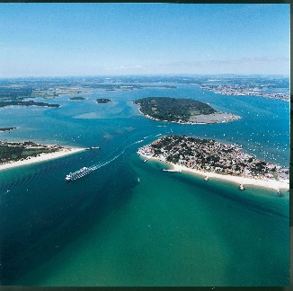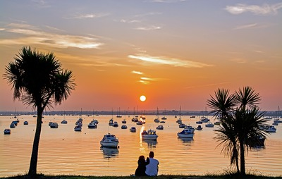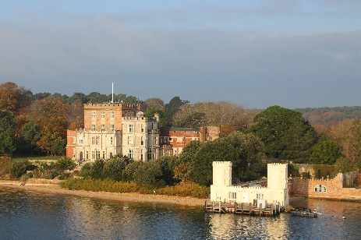
In House DJ – Rob
£230.00 extra
Rob is one of our regular DJ’s with a wide variety of music. If you wish to specify the genre of music you want played at your event then please let us know.
Want to bring your own DJ?
£60.00 extra
We can accommodate your own DJ at a small charge of £60.00 this would be for a music license to play your own music on board our vessel.
We would also need for the equipment to be PAT tested. This is to certify that the equipment you wish to bring on board our vessel and plug in is safe to use. We would need these documents sent to us at least 2 weeks prior to departure.
Mobiles and Tablets
£60.00 extra
We do accept mobiles and tablets to be linked to our sound system if you wish to play your own music.
This would be via a Bluetooth or usb connection. We would also need you to purchase the music license with us for £60.00 to do this.

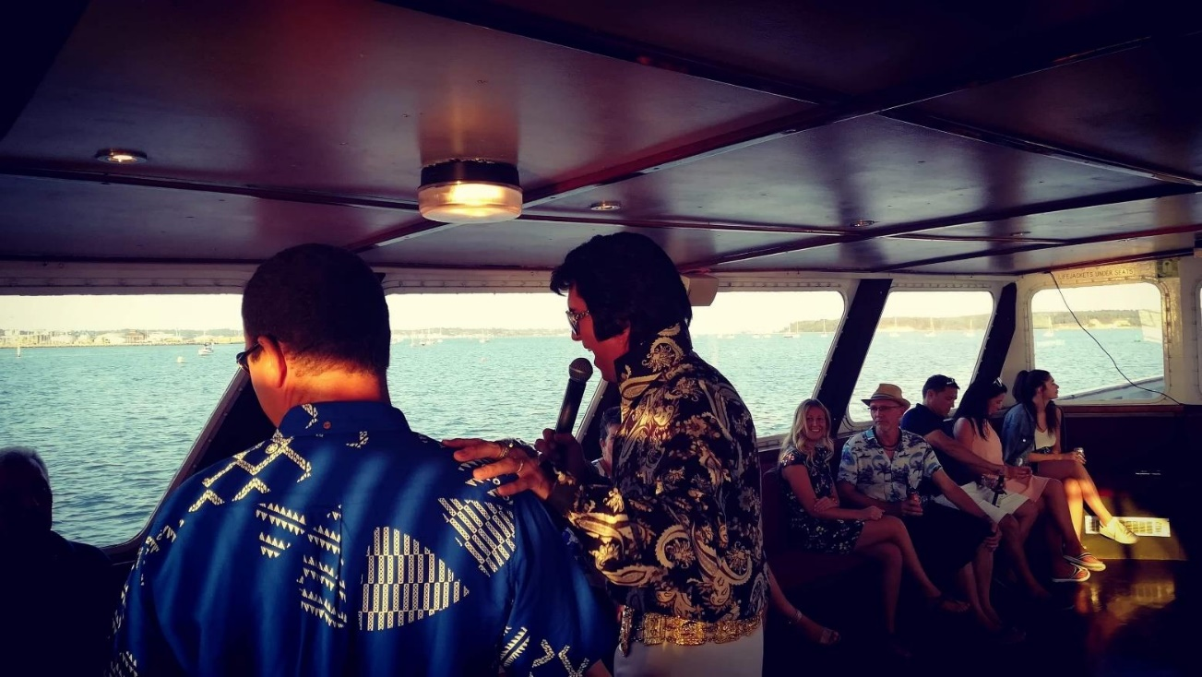
ENTERTAINMENT

Shirley Bassey Tribute Artist
Subject to availability
Debbie Farrell is one of the world’s best Shirley Bassey tribute artists. She also specialises in motown & soul music, for your entertainment.

Elvis Tribute Artist
Subject to availability
Garry Foley is a multi-award winning Elvis tribute artist and has performed throughout the UK, Europe, USA and Asia in theatre productions, weddings, parties & functions and corporate events. He also regularly performs on our themed evenings in the summer season and could be available to play at your event!

Freddie Mercury Impersonator
Subject to availability
Billy West has been named Europe’s best Freddie Mercury impersonator. With 20 years’ experience paying tribute to Freddie, for nearly 3500 performances, he is could be just what your charter needs.

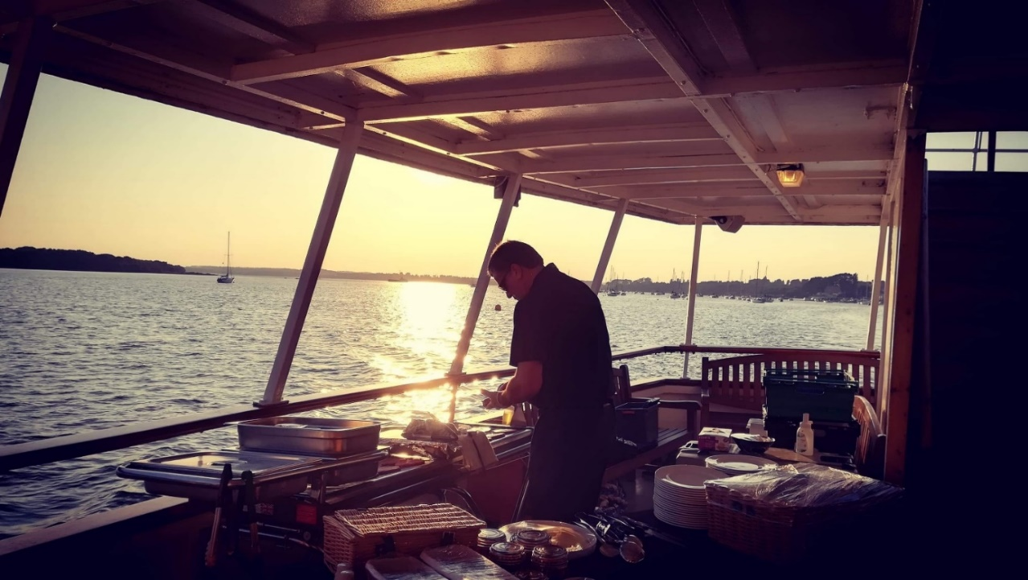

MENU OPTIONS
CATERING

Barbecue Cruise Packages from £15.00 per person (min 30 pax)
Finger Buffet from £16.80 per person (min 25 pax)
Fish & Chips from £13.85 per person (min 20 pax)
Canapés From £3.00 each (Min 3 canapes pp &
min 40 pax)
Pizza (Half metre) From £36.00 for 12-15 slices
Paella Pan From £9.60 per person (min. 25 pax)

We work closely with multiple local food caterers to provide you with the best quality catering for your occasion. All our catering options are also very flexible with vegetarian, vegan and gluten free alternatives to cater for all your guests. Please let us know of any special dietary requirements you require when choosing your menu.

Please see a more detailed view of each menu below.

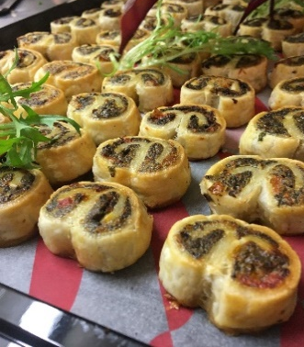
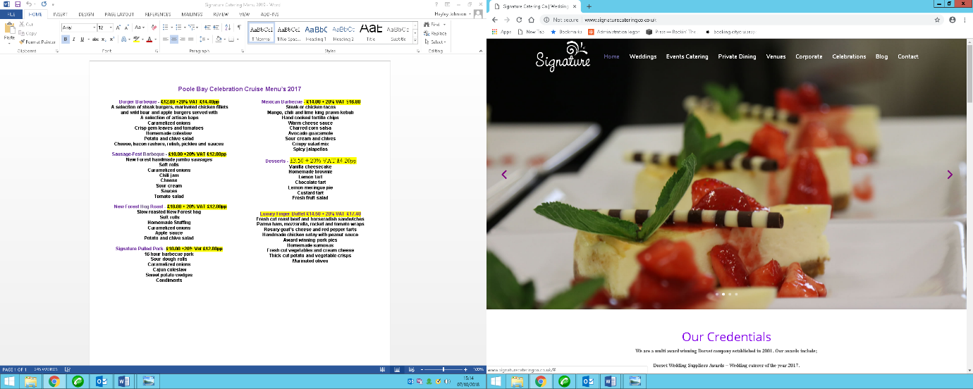
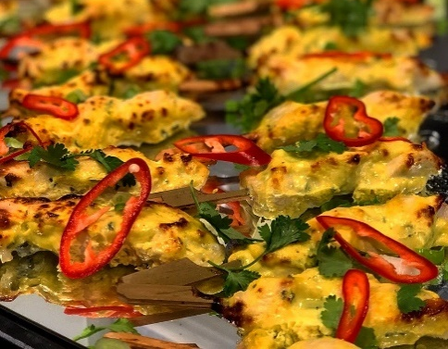
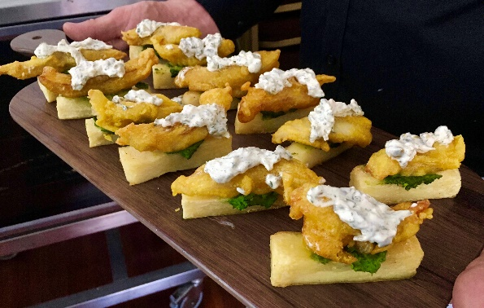
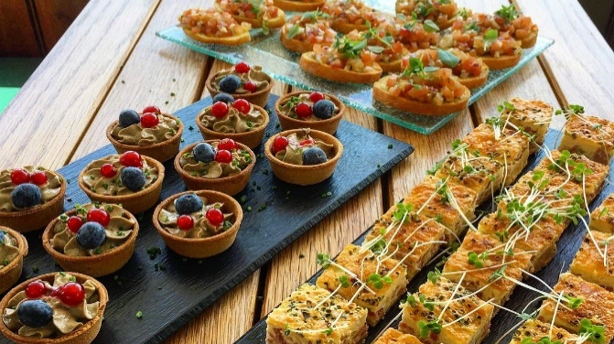

Pulled Pork Baps @ £15.00 pp (min 20 pax):
Locally Sourced Slow Cooked Pulled Pork, BBQ Pulled Vegan Jackfruit
Served with: Traditional Sage and Onion Stuffing, Apple Sauce, Succulent Crackling, New Potato and Chive Salad,
Coleslaw, Crusty Sour Dough Rolls

Classic BBQ Menu @ £18.00 pp (min 20 pax)
New Forest Steak Burger, Plant based Moving Mountains Burger
Served with: Coleslaw, Potato and Chive Salad, Mixed Leaves Salad with Seasonal Dressing, Crusty Sour Dough Rolls,
Selection of Relishes and Sauces
Dessert: Homemade Cake Treats

Gourmet BBQ @ £24.00 pp (min 20 pax)
New Forest Steak Burger, Chef’s Marinated Chicken Breasts, Plant based Moving Mountains Burger, Local Pork Sausages
Served with: Coleslaw, Potato and Chive Salad, Basil and Sundried Tomato Pasta Salad, Mixed Leaves Salad with
Seasonal Dressing, Crusty Sour Dough Rolls, Selection of Relishes and Sauces
Dessert: Homemade Cake Treats
FOOD MENUS

Fish & Chips @ £13.85 per person:
Cod & Chips 7/8 oz
1 x Jumbo Sausage (Battered or Plain) & Chips
Chicken Leg & Chips
Veggie Burger & Chips
Child Option @ £6.50 per person
Fishcake & Chips
1 x small Sausage & Chips
Cheese & Onion Fryit & Chips

Minimum of 20 people

FINGER BUFFET @ £16.80 per person:
- Fresh Cut Sandwiches

- Gourmet Sausage Rolls

- Baked Tartlets

- Samosa and Onion Bhaji Platter

- Burt’s Crisps

- Homemade Cakes
Minimum of 20 people

Charcuterie and Mezze Platter @ £26.40 per person:
- Local Cheeses

- Dorset Ham, Tender Sliced Beef and Pastrami

- Variety of Cured Meats

- Chef’s Aioli

- Homemade Sweet Chilli Hummus

- Crudites

- Marinated Olives and Stuffed Peppers

- Crackers

- Bread Sticks

- Selection of Breads

- Homemade Cookies

Cuisine Buffet @ £20.40 per person:
- Fresh Selection of Wraps

- Marinated Chicken Skewers

- Vegetable Spring Rolls with Sweet Chilli

- Duck Spring Rolls

- Homemade Quiche

- Homemade Chef’s Potato Salad

- Crusty Roll Selection with Butter

- Mixed Leaf Salad with Honey and Mustard Dressing

- Homemade Cakes

Canape Options

£3.00 each Minimum of 3 canapes per person for a minimum of 40 people

- Mini Toad in the Hole

- Feta Bruschetta
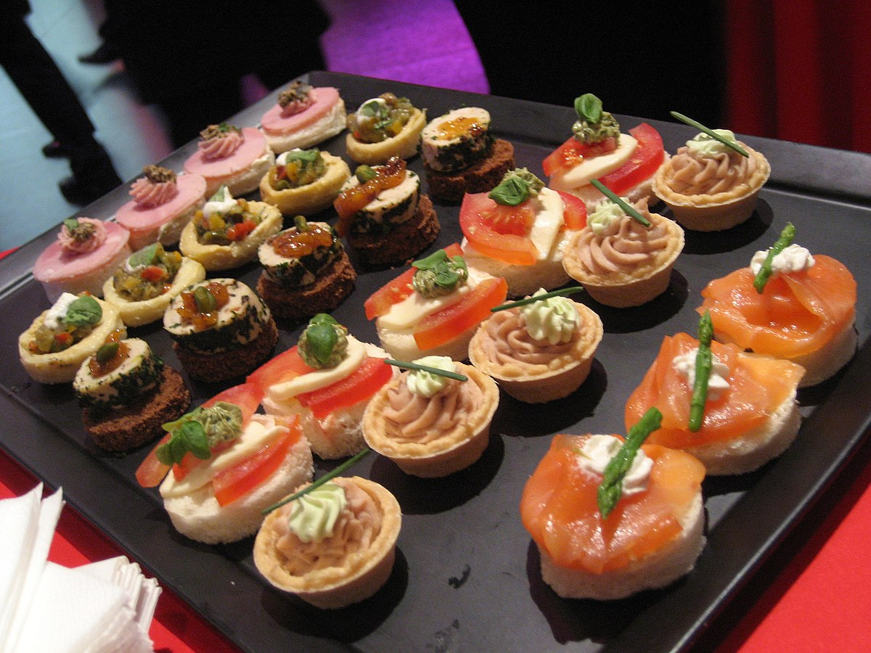
- Prawn Vol au Vents

- Honey Roast Pig in Blankets

- Tandoori Chicken Skewers

- Smoked Salmon and Dill Blinis

- Beetroot and Whipped Goats Cheese Cups

- Mini Baked Tartlets

- Tomato and Mozzarella Skewers

Cream Tea Menu @ £11.50 per person (available in an individual box) (min 25 pax)
Dorset Scones
Strawberry Jam
Clotted Cream
Tea and Coffee

High Seas Afternoon Tea @ £19.80 per person (available in an individual box) (min 20 pax)
Selection of Finger Sandwiches (Coronation Chicken, Free Range Egg Mayonnaise and Cress, Mature Cheddar and Local Chutney, Dorset Ham Salad)
Baked Tartlets (Bacon ad Leek, Red Pepper and Goats Cheese)
Homemade Pork Sausage Rolls (vegan option available)
Dorset Scones with Strawberry Jam and Clotted Cream
Homemade Sweet Treats
Milk and White Chocolate Dipped Strawberries
Tea and Coffee

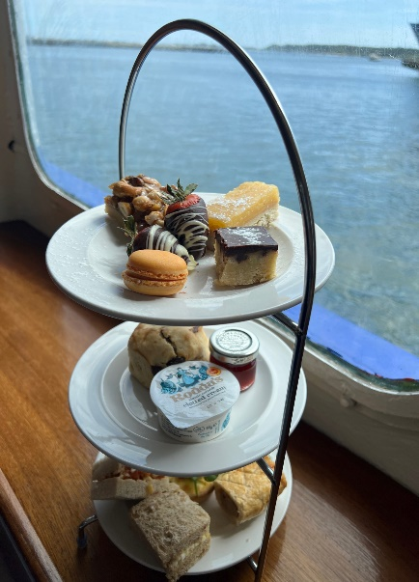

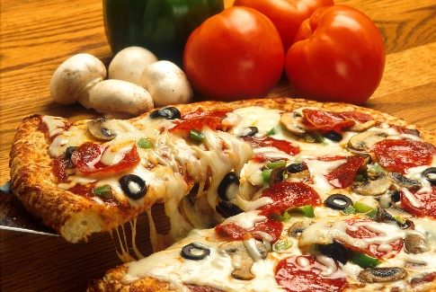
Pizza Buffet
Half Metre Pizza (12/15 slices)
Choose from:
-Maialina £45.00
(Sourdough base with tomato sauce, fiordilatte mozzarella, bacon, pepperoni, chicken and meatballs)
-Monnalisa £36.00
(Sourdough base with tomato sauce, fiordilatte mozzarella, ham & mushrooms)
-American hot £36.00
(Sourdough base with tomato sauce, fiordilatte mozzarella, pepperoni and chilli)
-Sea Food £48.00
(Sourdough base with tomato sauce, fiordilatte mozzarella, calamari, mussels and king prawns)
-4 Stagioni 42.005 (Vegan on Request)
(Sourdough base with tomato sauce, fiordilatte mozzarella, olives, onions, mushrooms and sundried tomatoes)
Gluten free base available only for 12" pizza.

Paella Pantastic (Solent Scene Boat only)
A Paella Mixta ( seafood & meat) with a separate Mexican vegan bean Paella.
25 - 50 guests = £14.50 per head
50 - 100 guests = £12.00 per head
100 - 150 guest = £9.60 per head
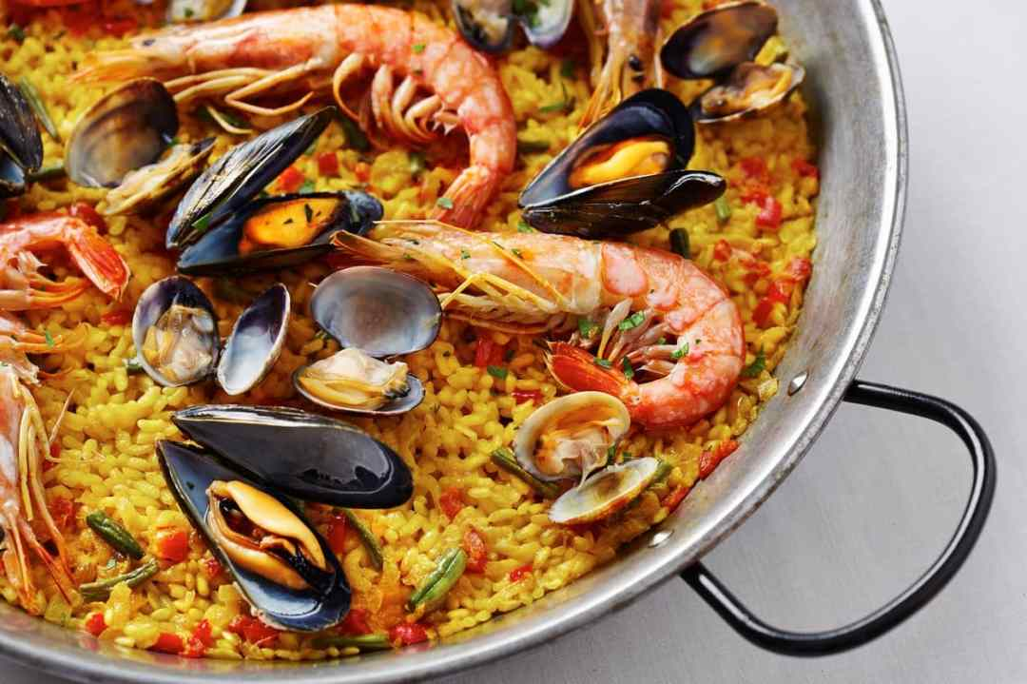

Mixed Salad and Olive Breads @ £2.40 per person
All is cooked in our pans on board and is quite a spectacle for guests for guests to enjoy and learn the art of making this great Spanish dish

Fancy something bespoke then just ask! Our caterers are always happy to put a special menu together for your event!

Reviews
Service, friendliness of staff and safety is always top-class.
– Jurassic Coast Trust
Don’t just take our word for it! Here’s what our customers have to say:

Well organised and everyone felt safe, the staff were really approachable and easy to build a rapport with which is important when it’s a relaxed social event! – Siemens PLC
It met all the requirements that I was looking for.
– Anonymous - Feefo

– Paul C
Great singer and staff were excellent. Thoroughly enjoyed the whole experience.


Scattering of Ashes at Sea
Many people request to have their ashes scattered in a location that holds some special meaning to them. This includes being scattered at sea and is particularly popular for people who have a fondness of the sea or have a nautical background. For the families this is a beautiful way to say a final farewell to their loved one in a peaceful & memorable setting.
City Cruises have been a popular choice for people to conduct a Scattering of Ashes ceremony on our Island Scene and our Captain and crew are there to ensure your wishes are met and the ceremony is held in a respectful and meaningful way.
The Island Scene is a perfect boat to hold a Scattering with Ashes with a large outside, covered rear deck and an indoor saloon with a licensed bar. Perfect for smaller family gatherings.

1 hour Scattering of Ashes Package
£450.00 boat hire
Enhancements
Licensed bar on site & drinks packages available
Catering available from £13.00 per person
Scattering ashes directly onto the water can sometimes lead to the ashes being blown which can be distressing for some of the family. We recommend a biodegradable urn that will dissolve in water and Scattering Ashes have a vast range to choose from
https://scattering-ashes.co.uk/cremation-urns/urns-for-water/

Charter Booking 2025
Post to Coastal Cruises Poole Ltd, Blue & White Kiosk, Poole Quay, Poole BH15 1HJ
OR email sales@coastalcruisespoole.co.uk Tel: 07483 038487
ORGANISER DETAILS
Name of organiser ________________________________________
Business Name ___________________________________________
Address _________________________________________________
Email ___________________________________________________
Telephone number ________________________________________
TRIP DETAILS
Date of trip _________________ No. of passengers _____________
Time 7.00pm – 10.00pm other (please state) ___________
Nature of trip (birthday, corporate) __________________________
OPTIONAL EXTRAS (please tick if required)
- IN HOUSE DJ £230.00
- MUSIC LICENCE £60.00 Type of music_____________
- WINE Quantity _____ Type__________________
- FOOD Quantity _____ Type__________________

ADDITIONAL INFORMATION
Special requests __________________________________________
________________________________________________________

Where did you hear about us ________________________________

SIGNED (I am over 18 and agree the conditions of carriage) _________________________
Print name _____________________ Date ____________________
*Deposit / balance can be made by card on 07483 038487

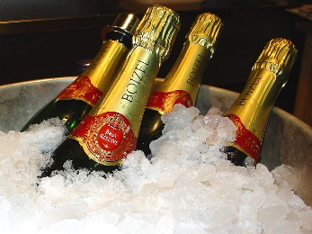

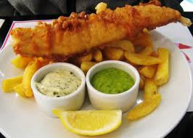

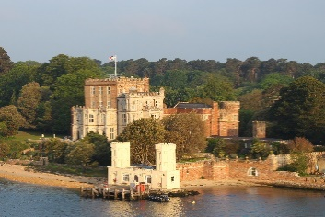
CONDITIONS OF CARRIAGE

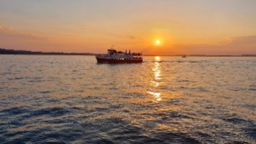



1. APPLICATION
These conditions apply whether a contract has been made verbally or in writing.
2. QUOTATIONS
All quotations are made subject to a vessel suitable for the Hirer's requirements still being available at the time of acceptance. Quotations are valid for 28 days from issue or for any period specified.
3. ROUTE VARIATION
Whilst every endeavour will be made to ensure that vessels run to the scheduled timetable, circumstances may prevail which prevent punctuality and, at all times the vessel will remain under complete control of the Master; the trip being varied if in his sole discretion this should be desirable for weather or any other cause beyond our control, the customer having no claim against Coastal Cruises Poole Ltd in the event of such deviation or variation.
4. PAYMENT
A 50% deposit is required at time of booking unless an alternate agreement has been made in writing beforehand. The balance will become due 14 days prior to sailing and must be paid on time or the cruise may be cancelled. Deposits are non-returnable in the event of cancellation by the customer. Where Catering and other services are required, 50% payment of these are due prior the cruise, and the whole amounts due may be payable if the trip is cancelled by the client for any cause.
5. CANCELLATION
Bookings are accepted on the understanding that payment is guaranteed for the numbers booked or the agreed rate for the hire of the vessel. No allowance can be considered unless advice is given early enough to allow Coastal Cruises Poole Ltd time to try and dispose of such bookings to an alternative customer and every effort will be made so to do. Nonetheless in the event that the booking is not re-sold the customer shall remain liable for the outstanding amount in full. In the event of failure by outside contractors, i.e. Disco, Caterers etc., that are arranged on the Hirer's behalf, the cruise charges which are separate will still be payable in full. Likewise, in the event of a cancellation of cruise due to any circumstances beyond our control (bad weather, mechanical failure etc.) we shall only be liable to refund cruise charges paid by the customer after deducting any expenses incurred on the Hirers behalf, and we will not be liable for any other expenses incurred by the Hirer.
6. CONDUCT / DRESS
The Master is responsible for the safety of the vessel, and for comfort of the passengers. Therefore a reasonable standard of dress is requested and it is desirable that particularly on evening functions this is adhered to. Ladies should be aware of the possibility of tripping on the landing stage and wear suitable flat shoes. Passengers must conduct themselves in a safe manner; the cruise may be cancelled at the Masters discretion if this is not the case, passengers must not climb onto the ships roof or onto the bow railings. Passengers must use the gangway to board the ship and any passenger not doing so will be refused passage. The Hirer is responsible for any damage caused by his party, and for advising his group of the conditions required, and that unless he has made prior arrangement, no drinks are to be brought aboard by them.
7. FOOD & DRINK
Under normal circumstances the company will allow on board no food or drink without written permission. Where permission is given it will be accepted that in most circumstances a corkage or service charge may be made. In the event of guests arriving with their own food or drink without such permission the company reserve the right to either retain such goods in safe custody until the end of the cruise or at the masters sole discretion to refuse boarding to such persons.
8. COMPLAINTS
Any complaints in respect of the services supplied must be registered during or before the end of the cruise to the Master, and in writing within 7 days.
9. CRUISE
Bookings are for the time specified on the Booking Form, although boarding can commence 15 minutes before sailing. Should the Hirer require time for setting up displays etc., then prior arrangements must be made with Coastal Cruises Poole Ltd and a charge may be made. In the case of party bookings for persons under 21 year olds a breakage bond will be required and the company shall stipulate the number of adults over 25 required to supervise the party.

10. TICKETED EVENTS
Ticketed events may be allowed on our vessels subject to Management discretion. We have the right to cancel your event at any point if we are to believe you have broken any agreement put in place. Should a ticketed event be allowed, then 1 security guard per 30 guests will be required, booked by City Cruises and charged back to the client. Maximum capacity 120 people. Guests will not be allowed to board the boat if already under the influence of alcohol.
11. TELEPHONE
Bookings can only accepted on receipt of the completed booking form and requested deposit. We are unable to accept bookings verbally by telephone, although we are able to indicate whether a date is available bookings are taken on the basis of the first booking form received.
12. PUBLICITY
Banners, Posters, and decoration of any kind can only be displayed by prior arrangement in writing. Depending upon the event, a charge may be made.

